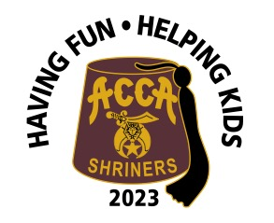
Acca Shriners Car Show
$25 Entry Fee
September 16, 2023

Pay online or send completed application and $25 payment to:
Acca Shriners, 1712 Bellevue Ave., Richmond, VA 23227, 804-264-0509 businessoffice@accashriners.com

Name: ________________________________________________________________ Address:_______________________________________________________________
City, State, Zip__________________________________________________________

All Makes and Models are Welcome

Car Description: ________________________________________________________
_____________________________________________________________________

Parts Vendor Space Available for $50.00

For additional information contact Michael Poegl 804-363-1080 email: mpoegl@gmail.com
Proceeds benefit Acca Shriners Transportation Fund

