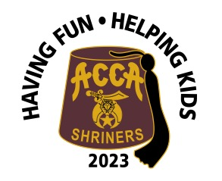
Sponsorship Application
Acca Shriners Car Show
September 16, 2023

Sponsorship Levels:
- Platinum Sponsor Donation $5,000
- Gold Sponsor Donation $2,500
- Silver Sponsor Donation $1,000
- Titanium Sponsor Donation $500
- Patron Sponsor Donation $100

Write below what should be printed on the Sponsor’s Banner

Information:
Name: _____________________________________________________________
Address: _____________________________Phone#________________________
City: ___________________ State: _____ Zip: _____email______804-363-1080______________

Amount paid _________ (make check payable to ACCA Shriners)

Send to:
Pay online or send to Acca Shriners, 1712 Bellevue Ave., Richmond, VA 23227, 804-264-0509 businessoffice@accashriners.com

Proceeds benefit Acca Transportation fund and deductible as charitable contributions. For more information contact Michael Poegl 804-363-1080 email: mpoegl@gmail.com

